Project Design Phase-II Data Flow Diagram

| Date | 17 november 2022 |
| --- | --- |
| Team ID | PNT2022TMID48113 |
| Project Name | Project - Detection of Parkinson’s Disease |
| Maximum Marks | 4 Marks |

# Data Flow Diagrams:

A Data Flow Diagram (DFD) is a traditional visual representation of the information flows within a system. A neat and clear DFD can depict the right amount of the system requirement graphically. It shows how data enters and leaves the system, what changes the information, and where data is stored.

# Flow:

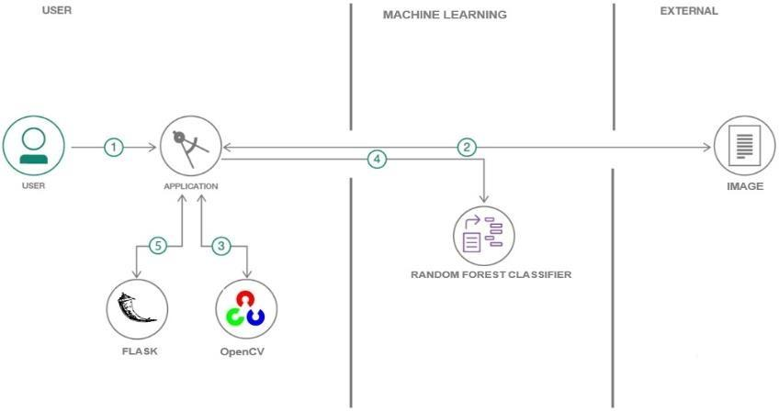

1. User configures credentials and starts the app.
2. User selects hand drawn images to process and load.
3. OpenCV does the image pre-processing.
4. The processed image is sent to the Random Forest Classifier.
5. The predicted output is visualised using Flask.